Experiment No:13

Aim:Detailed study of BI tool IBM COGNOS.

Theory:

IBM Cognos Business Intelligence is a web-based integrated business intelligence suite by IBM. It provides a toolset for reporting, analytics, scorecarding, and monitoring of events and metrics. The software consists of several components designed to meet theBasic components  
The elements described below are web-based components that can be accessed from most popular browsers (IBM Cognos specifically supports Mozilla Firefox, Google Chrome and Internet Explorer).  
  
Cognos Connection  
Cognos Connection is the Web portal for IBM Cognos BI. It is the starting point for access to all functions provided with the suite. Using this portal, content can be searched in the form of reports, scorecards and agents, it can be managed, structured and displayed. In addition, the portal is used for multiple functions, for example to schedule and distribute reports, for creating tasks, administering the server and the access permissions to content available to different users. You can also create shortcuts, URLs and pages.  
  
Query Studio  
Query Studio allows simple queries and self-service reports to answer basic business questions. The report layout can be customized and data can be filtered and sorted. Formatting and the creation of diagrams is also supported.  
  
Report Studio  
The Report Studio is used to create management reports. It offers two different modes: The professional authoring mode enables users to access the full range of Report Studio functionality. In this mode, users can create any type of report, including charts, maps, lists, and repeat functions. In professional authoring mode all types of Data (relational or multidimensional) can be used, but dynamic data can not be displayed.

The express authoring mode has a more simple user interface, designed for non-technical users. It enables them to create traditional financial or management reports in a more focused user interface. In contrast to the professional authoring mode, the express authoring mode allows the use of dynamic data. different information requirements in a company. IBM Cognos has components such as IBM Cognos Framework Manager, IBM Cognos Cube Designer, IBM Cognos Transformer.

### **Analysis Studio**[[edit](https://en.wikipedia.org/w/index.php?title=IBM_Cognos_Business_Intelligence&action=edit&section=5)]



Analysis Studio  
OLAP-functionalities  
Drill-up and drill-down as example OLAP-functionalities  
Users can create analyses of large data sources and search for background information about an event or action. Multidimensional analysis allows identifying trends and understanding of anomalies or deviations, which are not obvious in other types of reports. Drag-and-drop features, elements and key performance indicators can be included in the analysis, rows and columns can be switched, OLAP-functionalities[2][3] like drill-up and drill-down can be used to get a deeper understanding about the sources of the information used in the analysis.

Result:

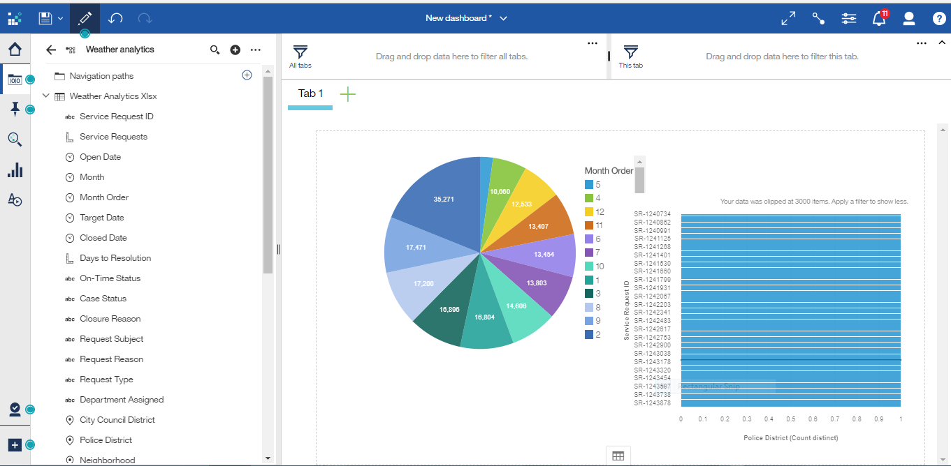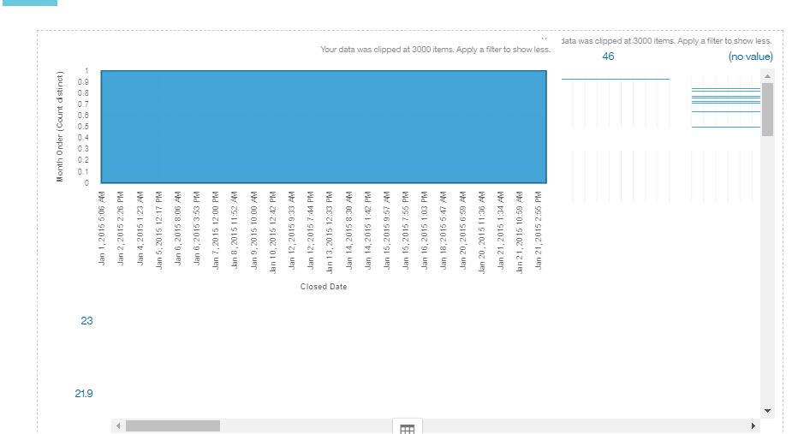

Conclusion:

Thus,We Used IBM Cognos for Analytics for weather data set.